Chris McKay - Ringing World Obituary
Chris McKay, BSc, C Eng, FBHI 4/5/1949 - 10/7/2023
Some ringers will be saddened by the unexpected death of Chis McKay who died suddenly aged 74 at his home in Hinton Martell, Dorset. Chris was taught to ring by Wilfred Wilson, the author of ‘Change Ringing’ at Christ the Saviour’s Church in Ealing, Middlesex in the early 1960’s. In the late 1960’s & 1970’s we rang together with the University of Sussex Guild of Change Ringers. Chris rang only one peal: Grandsire Triples in 1974 at Ealing conducted by Frank Blagrove with a notable band comprising Harold & Olive Rogers with their son Chris, Tom Lock, Geraldine Lea (Geraldine Forster ) & Michael Sprackling.

He was an electronics engineer initially working on designing Automatic Testing Equipment and later became involved with technical sales and marketing. On leaving the electronics industry he took up teaching design and technology at a number of schools in Dorset.
Ringers may be more familiar with his name if they have a clock in their church tower since his main interest was in turret clocks and he was recognised as a world expert. Chris was a member of the Antiquarian Horological Society and a Fellow of the British Horological Institute. He authored numerous books, articles and letters relating to clocks, including The Turret Clock Keeper’s Handbook which may be found in many towers.

Chris consulted and worked on clocks as far afield as Argentina, Australia ( The Swan Tower, Perth) Canada, Ghana and Italy; and he was awarded a Gold Medal by the Mayor of Chioggia, Italy¹⁰ for his contribution to turret clocks, He maintained a number of church clocks in Dorset and was the Salisbury DAC clock adviser.

In later years, Chris rarely rang other than when he regularly stayed at Chertsey. He regilded the St Peter’s Church Chertsey dials for the Millenium in 2000 AD and together we refurbished the 1892 Smith’s of Derby clock movement in 2006, which he used as an example in his book ‘The Maintenance, Repair, Restoration, Conservation and Preservation of Turret Clocks’ published in 2016 which has become an essential reference work. He also helped in the regilding of the weather vane and cockerel for Chertsey church in 2012.
Whilst working at NPL, I was involved in the 1976 failure investigation into the Big Ben clock. For the Institute of Mechanical Engineers seminar which reported the finding of the investigation I was keen that we put the cause of failure in an historical context so I enlisted Chris to help in researching the history of the clock. This he continued for the next thirty years culminating in his book on Big Ben, published by Oxford press in 2010.
He was an active participant in village life including restoring and maintaining the village fountain. As recently as 4th June 2023 he acted as Master of Ceremony for the Coronation celebrations in Hinton Martell.

Chris was a big hearted generous man and willingly sharing his encyclopaedic knowledge of turret clocks and he trained a number of people in the practical skills of clock restoration and gilding.
His funeral will be a woodland burial near Winborne, Dorset for family and close friends on 16th August followed by a Memorial Service at a later date to be arranged.
He is survived by an older sister, and he will be sadly missed but fondly remembered as a mentor and friend by a wide circle of people from the world of clocks, ringing, his work, Scouting, education as well as his local community. His legacy is an extensive range of publications and many clocks that he restored that will run for generations; Chris achieved much, possibly because he was a workaholic and did not own a TV!
Malcolm Loveday, Chertsey, July 2023

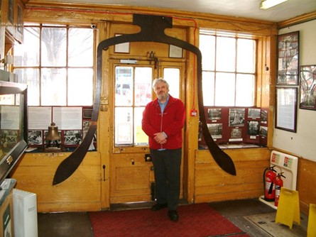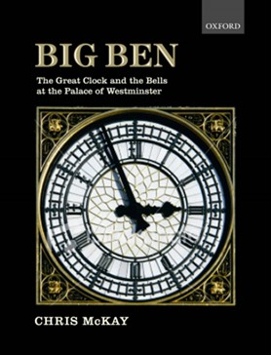

Chris McKay standing inside the profile of Big Ben at the Whitechapel Foundry,
London, circa 2010 [ photos : Malcolm S Loveday ]

