Chris McKay - Obituary
Chris McKay, BSc, C Eng, FBHI 4/5/1949 - 10/7/2023
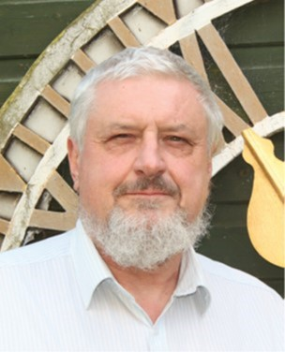
Chris with his garden shed clock dial in the background, Hinton Martell, Dorset.
Many people in the clock world will be saddened to learn of the death of Chris McKay who died suddenly, aged 74, at his home in Hinton Martell, Dorset.

Chris had Scottish heritage and was born in Sutherland, Scotland in May 1949. His father was in the police force and the family moved south to West London, initially to Ealing and subsequently to Greenford. When he was 11 years old, he attended a local grammar school where his games lessons were held at the Hanwell Community Centre and the building has a turret clock. This is where the seed of the world of turret clocks was planted.
Although from a young age he had taken alarm clocks apart, his true beginnings into turret clocks happened in 1969, when along with John Scott, David Birt¹ and John Taylor, he worked on the restoration project of the Hanwell Community Centre (West London) turret clock². He joined the Antiquarian Horological Society (AHS) and became a member of the Turret Clock Group (TCG) in 1969 and subsequently became Treasurer of the TCG in 1977 and Secretary in 1981 a position he kept till 1986 when he reverted to being Treasurer again. He became Vice-Chairman in 1990 moving to Chairman in 1992 for 12 years thus amassing a total of 27 years as an officer to the group. He remained an active member of the TCG until his death, having been member for over 50 years.
He joined the British Horological Institute, was a director for the BHI from July 2007 to July 2009, becoming a FBHI in November 2013.

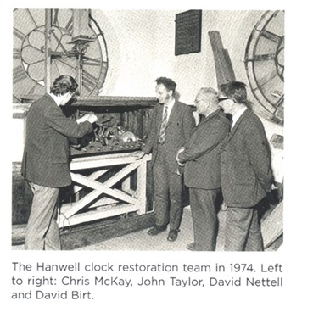
Chris was also a bell ringer, having been taught to ring by Wilfred Wilson, the author of ‘Change Ringing’³ at Christ the Saviour’s Church in Ealing, Middlesex in the early 1960’s. In the late 1960’s & 1970’s he rang with the University of Sussex Guild of Change Ringers but he only rang one full length peal: Grandsire Triples in 1974 at Ealing lasting 2 hours and 53 minutes⁴.
His main interest was in turret clocks and he became recognised as a world expert, with an encyclopaedic knowledge of church clocks. He authored numerous books, articles and letters relating to clocks, including The Turret Clock Keeper Handbook⁵ which may be found in many towers. As a ringer, he fully appreciated the importance of the correct positioning and maintenance of clock hammers striking on bells hung for full circle ringing.

Following graduation in the early 1970’s he served a brief spell in the Civil Service based in Barry, South Wales, fitting electronic equipment on an oceanographic research vessel, however he did not seem over enamoured with civil service bureaucracy, so he left to join the commercial electronics industry; initially working on designing Automatic Testing Equipment (ATE) and later he became involved with technical sales and marketing. He moved to Fleet, Hampshire, closer to where he worked. When the firm relocated to Dorset in the early 1980’s and he moved to Hinton Martell, about 4 miles north of Wimborne.
Chris was very much a people person and easily fell into the role in technical marketing of ATE for Schlumberger and thus travelled widely. On leaving the electronics industry at the beginning of the 2000’s, he continued to use his communication skills, taking up teaching design and technology at several schools in the Dorset area.

Whilst working at the National Physical Laboratory (NPL) I was involved in the 1976 failure investigation into the Big Ben clock. For the Institute of Mechanical Engineers seminar which reported the finding of the investigation, I was keen that we put the cause of failure in its historical context. I enlisted Chris, with whom I had rung and looked at turret clocks since the late 1960’s, to help research the history of the clock which was published in 1981⁶ and which he continued for the next thirty years culminating in his book on Big Ben, published by Oxford press in 2010⁷.
Those with long memories may recall their participation in ‘The Great Salisbury Clock Trial’, held in the Medieval Hall, Salisbury in May 1993, organised by Chris with Mike Bundock acting as the presiding judge. The proceedings were produced as Monograph 2 published by AHS Turret Clock Group, edited by Chris McKay⁸. A report of the meeting by Brian Sparks was published in Antiquarian Horology⁹.

Chris organised the first Turret Clock Forum in 2008, held at the BHI Headquarters at Upton Hall, and ran it on his own for several years until Derek Frampton joined him in 2016, when they ran it together. It is now run by the AHS Turret Clock Group.

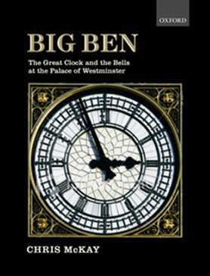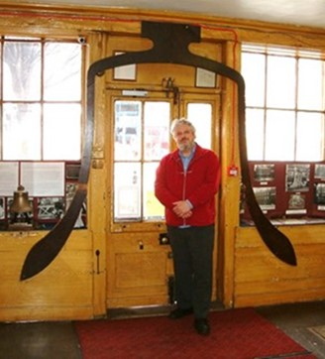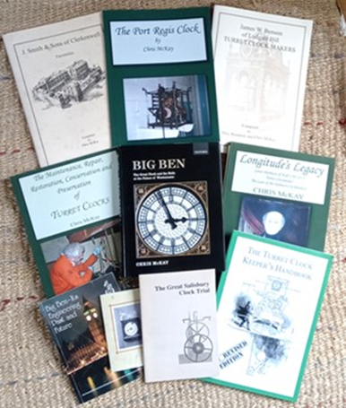

Chris McKay standing inside the profile of Big Ben at the Whitechapel Bell Foundry, A selection of publications
London, circa 2010 [ photos ; Malcolm S Loveday ]

Another innovation was establishing Turret Clock Taster days to introduce those interested in turret clocks to gain further hands-on experience on a one-day course.
Chris consulted and worked on clocks as far afield as Argentina, Australia (The Swan Tower, Perth), Canada, Ghana, Italy etc. Chris visited Italy several and guided by Dr-Ing Marisa Addomine, they visited all the most important astronomical turret clocks. Chris was welcomed by all the turret clock-keepers and by authorities. Their visits were reported in newspapers and on local television programmes. Places they visited included Padua, Clusone, Cremona, Florence & at Chioggia he was awarded a Gold Medal by the Mayor¹⁰ for his contribution to turret clocks.

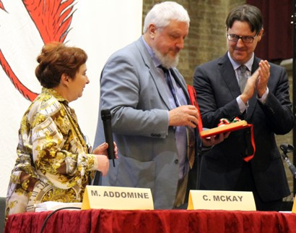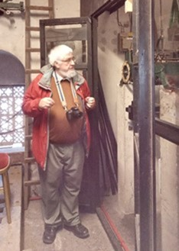
Gold medal presentation, Italy, 2013 Chris explaining details of the Chris dressed as Master
Cardiff Castle clock to members of Ceremonies for the
of the AHS Turret Clock Group tour, Coronation celebrations
Glamorgan, March 2023 in Hinton Martell, June 2022

Most people in the turret clock world will be familiar with his Turret Clock Keeper’s Handbook, the new revised version being issued in 2013⁵ and The Maintenance, Repair, Restoration, Conservation and Preservation of Turret Clocks’ published in 2016¹¹ is also useful reading.
Another of his lifetime’s interest was the grasshopper gravity escapement culminating in his book on John Harrison of Hull published in 2015¹².
He also issued a number of facsimiles of articles of Clock Makers catalogues, including J Smith & Son of Clerkenwell¹³ (issued in 2001), James W Benson of Ludgate Hill- Turret Clock Makers¹⁴, (co-authored with Mike Bundock) issued in 2002 and Bailey’s Illustrated and Useful Inventions¹⁵ , issued in 2017.

In addition, he authored numerous articles and letters published in the BHI & AHS Journals and other clock publications, including additional articles on Big Ben¹⁶⁻²⁰ and other topics ²¹⁻²².

For many years Chris Chaired of the Dorset Clock Society (DCS) and also acted as the Salisbury Diocese Clocks Adviser for the Diocesan Advisory Committee (DAC) dealing with Faculty applications. He made a significant contribution to the DAC Clocks Advisers Forum (CAF) document ‘A Code of Practice for Turret Clock Work’. The Code started in the CAF, an email forum for diocesan clocks advisers, where it went through many iterations and was then passed to turret clock companies and restorers for their comments which were incorporated into the published version available on the CAF and ChurchCare websites.

In later life, he continued to expand his interests and joined the Historical Metallurgical Society, see https://historicalmetallurgy.org/ attending a number of seminars and tours. Similarly, he enjoyed the recent March 2023 tour in Glamorgan organised by the TGC looking at turret clocks in the Cardiff & Barry area when he was happy to share his knowledge of the Cardiff castle clock with the assembled members.

In later years, Chris rarely rang bells other than when he regularly stayed at Chertsey. He regilded the St Peter’s Church Chertsey dials for the Millenium in 2000 AD and together we refurbished the 1892 Smiths of Derby clock movement in 2006 which he used as an example in his book ‘The Maintenance, Repair, Restoration, Conservation and Preservation of Turret Clocks’¹¹ which has become useful reference work. He also helped in the regilding of the weathervane and cockerel for Chertsey church in 2012 and gave tuition on gilding at various TCG meetings.

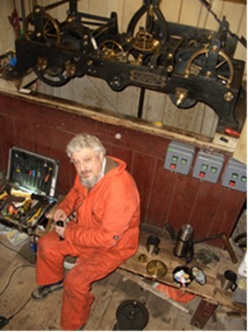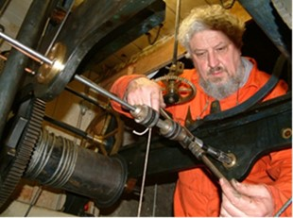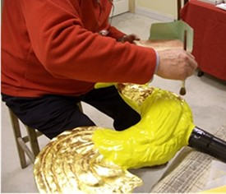

Refurbishing the Chertsey clock, 2006 Regilding the Chertsey weather vane, 2009
.
His last publication was a well-researched history of The Port Regis Clock (issued in 2023)²³ which he had restored over twenty years earlier. He maintained and repaired a number of local church clocks in the Wimborne / Christchurch area²⁴ and was a friend of Wimborne Museum.
He recently acquired a regulator made by Henry Ward of Blandford which required some restoration and is now in good running order. It was to be the subject of a talk for the DCS but fortunately with Chris’s usual thoroughness he had prepared a comprehensive article which hopefully someone will be able to prepare an appropriate presentation.
He also had a fantastic archive post card and photograph collection of clocks in addition to associated memorabilia which hopefully will find a home where they will be available to horological students and researchers.
Chris was an active participant in village life in Hinton Martell, restoring and maintaining the village fountain. As recently as 4th June 2023 he acted as Master of Ceremonies for the Coronation celebrations in Hinton Martell.
Many of us, not least Chris, were saddened by the sudden death of Mike Bundock²⁵ earlier this year and Chris was starting to collate Mike’s notes for a book on free standing public clocks, hopefully this task can now be continued by someone else.

Chris was a big hearted generous man and willingly shared his encyclopaedic knowledge of turret clocks, training a number of people in practical skills of clock restoration and gilding.
His funeral will be a woodland burial near Winborne, Dorset for family and close friends on 16th August followed by a Memorial Service at a later date to be arranged.

He is survived by an older sister, and he will be sadly missed but fondly remembered as a mentor and friend by a wide circle of people from the world of clocks, ringing, work, Scouting, teaching, as well as the local community. It was a privilege to have known Chris as a friend or an acquaintance; his legacy is an extensive range of publications and the skills he passed onto many as a teacher and clock restorer; Chris achieved much, possibly because he was a workaholic and did not own a TV!
Compiled by Malcolm Loveday, (Chertsey), July 2023 with contributions from Marisa Addomine, Andy Burdon, Derek Frampton, Simon Gilchrist, Sue Loveday, Keith Scobie-Youngs & Jon Taylor.
References

- Chris McKay David Birt – Obituary – Antiquarian Horology Vol 40 . p31 March 2019
- Chris McKay Two Poor Law Clocks - Antiquarian Horology Vol 38 . p221-238 June 2017
- Wilfred G Wilson, ‘Change Ringing – The Art and Science of Change Ringing on Church and Hand Bells. Pub: Faber and Faber, London 1965
- Ringing World 1974 see https://bb.ringingworld.co.uk/view.php?id=1412135
- Chris McKay The Turret Clock Keeper’s Handbook ISBN -13:978-1492317708 & ISBN -10: 1492317705. Self Published by author, Printed by CreateSpace, distributed by Amazon. 2013
- M S Loveday and C G McKay ‘Big Ben’-The Design and Construction of the Great Clock of The Palace of Westminster A1-17 in Big Ben- Its Engineering Past and Future. Institution of Mechanical Engineers,1981
- Chris McKay Big Ben- The Great Clock and the Bells at the Palace of Westminster Oxford University Press ISBN 988-0-19-958569-4 . 2010
- Chris McKay The Great Salisbury Clock Trial -How Old is the Clock? Proc Turret Clock Group Meeting 1st May 1993, Salisbury AHS Monograph No.2. Pub : Turret Clock Group 1993
- Brian Sparks The Great Salisbury Clock Trial – Meeting report Antiquarian Horology Vol 21, p 32, Autumn 1993.
- Chris McKay A Turret Clock in Chioggia Antiquarian Horology Vol 34 . p329-330 September 2013.
- Chris McKay The Maintenance, Repair, Restoration, Conservation and Preservation of Turret Clocks’ ISBN -13:978-1517127206 & ISBN -10:1517127203. Self Published by author, Printed by CreateSpace, distributed by Amazon. 2016
- Chris McKay Longitude’s Legacy- James Harrison of Hull 1792-1875 Turret Clockmaker- The Last of the Harrison Clockmakers ISBN -13:978-1511810333 & ISBN -10: 1511810335. Self Published by author, Printed by CreateSpace, distributed by Amazon. 2015
- Chris McKay J Smith & Son of Clerkenwell Pub: Pierhead Publications, Herne Bay, Kent. ISBN 0-9538977-2-9. 2001
- Mike Bundock and Chris McKay James W Benson of Ludgate Hill- Turret Clock Makers Pub: Pierhead Publications, Herne Bay, Kent. ISBN 0-9538977-7-X . 2002
- Chris McKay Bailey’s Illustrated and Useful Inventions’ issued in 2017.
- Chris McKay Big Ben – New Discoveries Part 1: Punch and the Bell Antiquarian Horology Vol 33. pp514-520, June 2012
- Chris McKay Big Ben – New Discoveries Part 2.. Antiquarian Horology Vol 33, pp799-802, December 2012.
- Chris McKay Big Ben as an electrical master clock Antiquarian Horology Vol 34 . pp235-239, March 2013
- Chris McKay Big Ben: What’s in the name? And a warning to Researchers Antiquarian Horology Vol 40. pp260-264, June 2019.
- Chris McKay The Westminster Clock Antiquarian Horology Vol 40. pp318-319, September 2019
- Chris McKay The Water Clock at Loch Head Dinnet Antiquarian Horology Vol 41. pp83-88, March 2020
- Chris McKay The Wellington Clock Tower of Swanage Antiquarian Horology Vol 41. pp505-520, December 2020
- Chris McKay The Port Regis Clock, ISBN 978375085197, Self Published by author, Printed by Kindle Direct Publications (KDP) , distributed by Amazon. 2023
- Jonathon Savill ‘Right time, right place’, Country Life, 29th November 52-54, 2017.
- Chris McKay Mike Bundock – Obituary – Antiquarian Horology Vol 44 . p20-21 March 2023

