BARRETT, BARRETT & OSBORNE, & C.S. OSBORNE (Bishopsgate, London)

Directories, census returns etc

1845 London Directory – No Osborne or Barrett in Skinner Street, Bishopsgate, and no brassfoundry there; Neither listed with brassfounders either
1846 Commercial Directory – Osborne not mentioned
1848 Post Office Directory – Osborne not mentioned
1851 Census return for 50 Wimpole Street, Marylebone – Emmanuel Barrett (he was a landed proprietor, aged 66, born in Jamaica) and children Arabella (37), Henri A (34), Alfred (30, brassfounder), Septimus (28, Barrister at Law) and Octavius (25, architect) – the children all born at Colwall, Herefs
[Also searched (twice) for Charles Stanley Osborne in 1851, 1861, 1871 and 1881 censuses – but not located]
1851 Advertisement in Worcestershire Chronicle, Wednesday 8 October 1851: Church Bells / Alfred Barrett / Bishopsgate Foundry, Skinner Street, London / Supplies Bells or Peals of Bells of the most superior quality of tone and highest finish, at the Low Price of One Shilling per lb. Peals of Bells re-paired and augmented, and Old Bells taken in Exchange.
1854 Kelly’s Directory – advertisement (p.28) of C.S. Osborne (late Barrett & Osborne), Bishopsgate Bell & Brass Foundry, Skinner Street, Bishopsgate, London

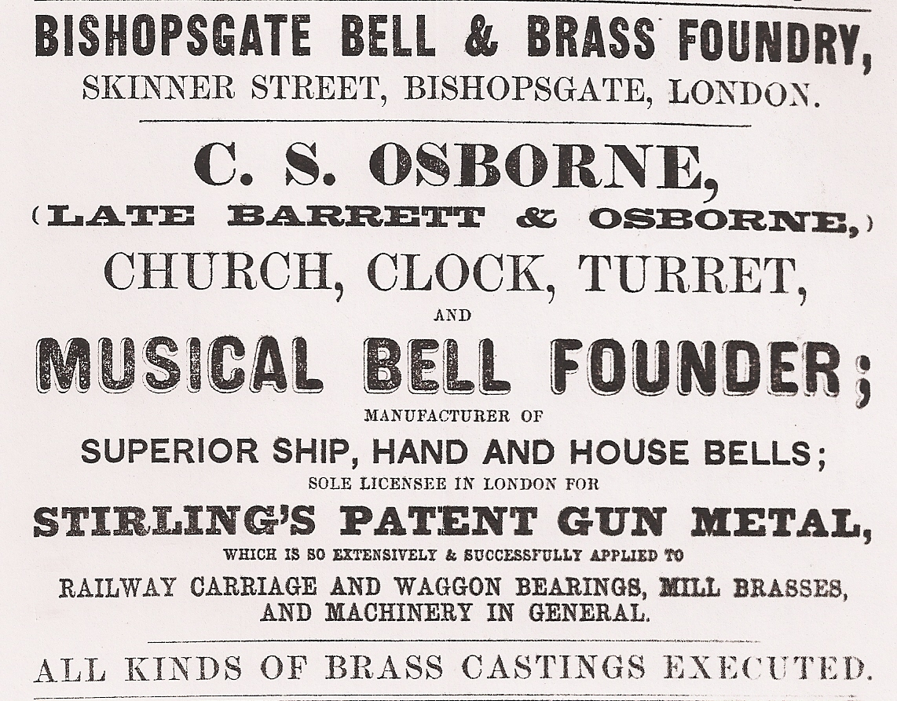

1855 Commercial Directory - Chas. Stanley Osborne, Bell & Brass Founder, Skinner Street, Bishopsgate
1857 Post Office Directory p.731 - Chas. Stanley Osborne, Bell & Brass Founder, Skinner Street, Bishopsgate, EC
The listed in directories at same address until 1870
1866 Legal processes by which Osborne took over lease of 4 Great Garden Street in the parish of St.Mary, Whitechapel, “with the warehouses, workshops, manufacturing lofts etc” previously held by Charles Venner (London Gazette 9 March 1866 p.1725)
1871 Directory – Chas. S. Osborne, 9 Gt. Garden St., Whitechapel, brass founder [bells not mentioned]
Entries continue until at least 1875
1881 Post Office Directory p.1143 – Osborne & Co Limited (Benjamin Taylor, sec.) brass & copper founders, metal & export merchants; depot for phosphor-bronze & other patent metals, Taylor’s special bearing metal, a superior anti-friction compound, cheaper than Babbit’s (sole manufacturers), 11 Great Garden Street, Whitechapel E
1882 Post Office Directory p.1148 – as 1881 exactly
1892 Post Office Directory p.1218 – Osborne & Co, brass, copper, gun metal, white metal phosphor bronze, founders & manufacturers, 11 Great Garden St., E – see advertisement (p.111)
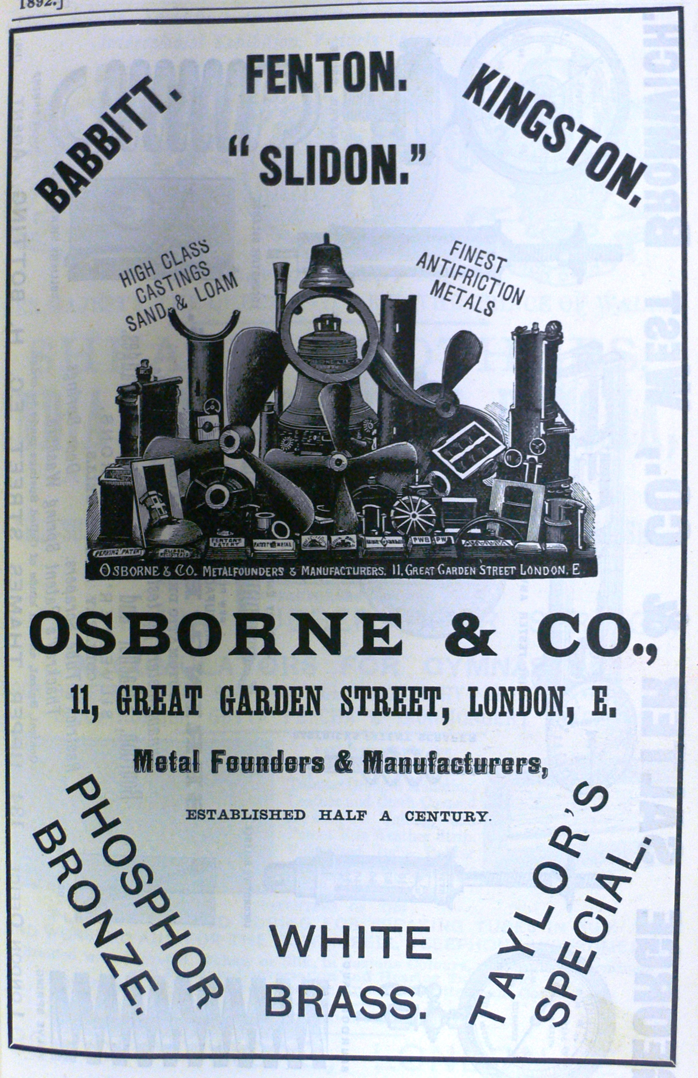

1896 Post Office Directory p.1294 – Osborne & Co, anti friction & white metal manufacturers, brass founders & metal manufacturers, 102 Fenchurch St, EC (late 11 Gt. Garden St, E); not in street directory at Great Garden Street
1899 Post Office Directory – firm gone. Not listed in brassfounders, nor in street directories at Great Garden Street or Fenchurch Street

Known bells by Barrett, Barrett & Osborne and C.S. Osborne (1852-1858)

Date | Founder and date | Location | Bell | Diam | Wt. | Notes | Source
1851 | Barrett, Alfred | North Malvern, Holy Trinity (Worcs) | 1 | 17 | 1¼ cwt | Architect, Daukes | ACB (6/10)
1851 | Barrett, Alfred | North Malvern, Holy Trinity (Worcs) | 2 | 21 | 2¼ cwt | Architect, Daukes | ACB (6/10)
1852 | Barrett, Alfred | St.Leonards on Sea, St.Mary Magdalene (Sussex) | 1 | 26¾” | 4 cwt | Architect, Marrable | Elphick (GPE 1/62)
1852 | Barrett & Osborne | Mark Beech, Holy Trinity (Kent) | 1 | 25¾” | 3½ cwt | Architect, Brandon | Pledger thesis, DLC 1/05
1853 | Barrett & Osborne | Cuminestoun, Episcopal Church (Scotland) | 1 | n/k | n/k | Recast | Clouston
1853 | Osborne | Thundridge, St.Mary (Herts) | 1 | 21 | 2¼ cwt | Scrapped around 1870s. Architect, Ferrey | Dodds, North
1854 | C.S. Osborne | Bengeo, Holy Trinity (Herts) | 1 | 18 | 1½ cwt | Priest's bell, scrapped 1882. Architect, Ferrey | Dodds, North
1856 | C.S. Osborne | Fosbury, Christ Church (Wilts) | 2 | 22¼” | 2½ cwt | Service bell. Architect, Teulon | Allan Keene (4/80)
1858 | C. Osborne | Fintray House (Scotland) | 1 | 22⅜” | 2½ cwt |  | Clouston

Notes on bells

From the known examples, it appears:
- The firm could cast bells of up to 27” diameter weighing up to 4 cwt (many smaller brassfounders only cast up to 20” or 2 cwt)
- Their bells were cast with full sets of six canons – and with usual mouldings
- The inscriptions are often (usually?) found on the high waist rather than in the inscription band
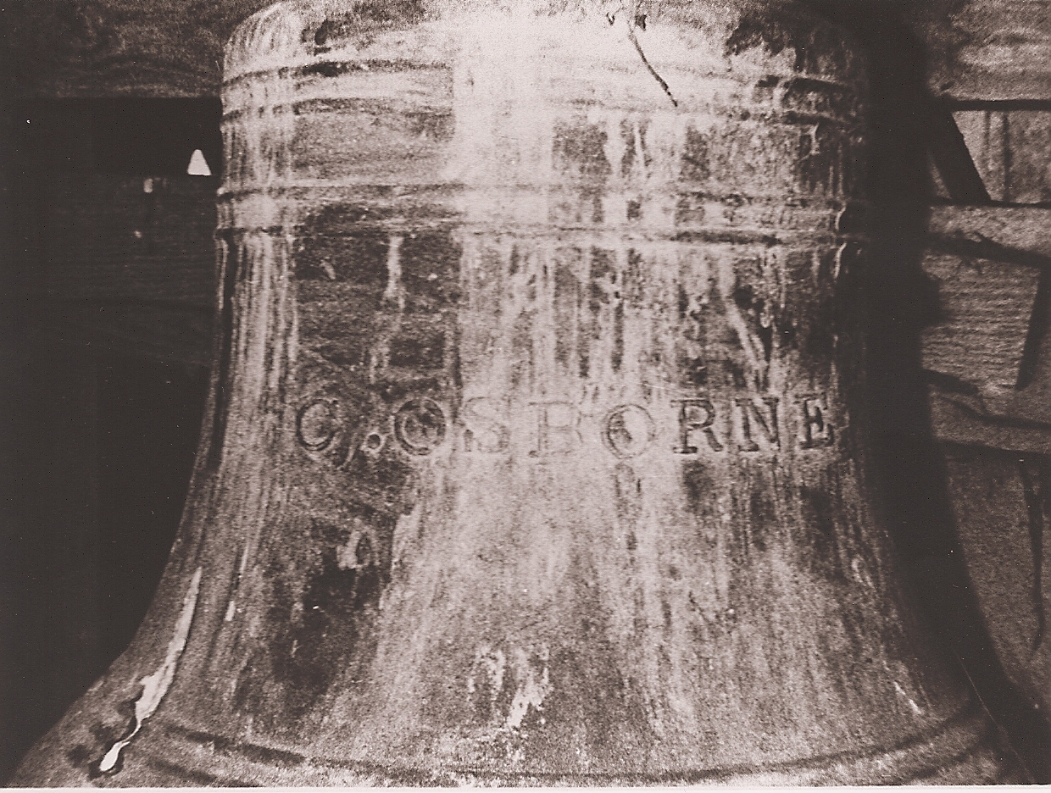
The Osborn bell (1856) at Fosbury, Wilts (photo: Allan Keene)

- Although no signed or dated bells after 1858 are known, it is interesting that bells are illustrated (one with canons and another with a peg argent) in the 1892 advertisement

Summary of business history (provisional)

c.1820 Alfred Barrett born at Colwall (the son of a Jamaican-born landed proprietor)

c.1835 Alfred Barrett presumably completed schooling and embarked on a trade

c.1840 Possible date of origin of business (the 1892 advertisement says “established half a century)

1841 Alfred Barratt (sic) living at 50 Wimpole Street with (father) Edward Barratt, and described as “Independent means”

c.1850 Brassfounding business established in Skinner Street, Bishopsgate, by Alfred Barrett

1851 Barrett cast two bells for Holy Trinity, Malvern - There were family connections with nearby Colwall, and Barrett’s younger brother Octavius was described in the 1851 census as an architect (by 1861, however, Octavius (lodging in Abergavenny) was a proprietor of houses, railway shares etc)

1852 Barrett cast the only other known bell made under his own name (St.Leonard’s on Sea)

1852 Barrett entered into partnership with C.S. Osborne, continuing and Barrett & Osborne

1852-3 Barrett & Osborne case two bells while in partnership (Mark Beech and Cuminestoun)

1853 Barrett withdrew from the partnership and the business continued in the sole name of C.S. Osborne, Bishopsgate Bell & Brass Foundry – at same address until c.1866 or c.1870

1853-8 Four further bells made by Osborne (Thundridge, Bengeo, Fosbury, Fintray)

1866 Osborne acquired lease of 4 Great Garden Street, Whitechapel. He is described in London Gazette 9 March 1866 p.1725 as Charles Stanley Osborne of no.36 Finchley Road, Middlesex, Brass Founder

1870 Osborne moved his works (as a brass founder) to 9 Great Garden Street, Whitechapel – continuing there until at least 1875

1881 By 1881 the firm was trading as Osborne & Co at 11 Great Garden Street, Whitechapel, with Benjamin Taylor as secretary

1896 By 1896 the firm, still Osborne & Co, had moved to 102 Fenchurch Street, evidently in a smaller way of business

1899 By 1899 the firm had disappeared

Barrett family – odd notes

Death registrations
- Septimus Barrett, died 1860, registered at Patrington, Yorkshire (East Riding)
- Harry Moulton Barrett, born about 1818, died 1896, registered at Honiton, Devon
- Edward Moulton Barrett, died 1857, registered at Marylebone
- Octavious (sic) B M Barrett, born about 1824, died 1910, registered on the Isle of Wight
- There were other (and earlier) Moulton Barretts, many in Devon

Probate calendars
- Alfred Price Moulton Barrett of Stockholmetchea, St.Jean-de-Luz, Basses Pyrenees, France, died 24 May 1904. Probate London 18 July to William Bridgman, retired major in H.M. army, and Alfred Wright Surtees, solicitor. Effects £3399 13s. 11d.

Hope End
- Accounts of the Barretts at Hope End in Anna Sproule Lost Houses of Britain (David & Charles, 1982) pp.175-9
- Burke Visitation of seats Vol.I p.54 (1854)
- Article in Country Life CXLIV (1968) p.715

Alfred Price Moulton Barrett
- According to the brief sketch of his life in Scott Lewis's edition of The Letters of Elizabeth Barrett Browning to Her Sister Arabella (2002), Alfred was employed by the Great Western Railway for a period after 1845, based at the Paddington Office. He also seems to have been employed as a government officer of some kind, spending time in Marseilles, Madeira and Hong Kong (Ex.inf. Joe Phelan, September 2010)
- In 1841 census at 50 Wimpole Street, Marylebone, with his family – listed as Alfred, 20, Independent means. Others in the household were George (25, Barrister), Henry (22, Independent), and James (18, Independent), None of the womenfolk there (in Devon?)
- In 1851 census at 50 Wimpole Street, Marylebone, with his family. The census lists Emmanuel Barrett (landed proprietor, aged 66, born in Jamaica) and children Arabella (37), Henri A (34), Alfred (30, brassfounder), Septimus (28, Barrister at Law) and Octavius (25, architect) – the children all born at Colwall, Herefs
- “It [i.e. the departure of Edward Moulton Barrett] was not the end of the family in Jamaica. Amongst the sons of Edward Barrett Moulton-Barrett was Alfred, born in 1820. In 1855 he [there must be some text missing here (CJP) – a marriage is suggested] his cousin Georgiana, daughter of George Goodin Barrett [this was Elizabeth Georgiana Barrett, his father’s cousin, who had been a ward of Edward Moulton Barrett]. They had four children. Their eldest son, Colonel Edward Alfred Moulton-Barrett, C.M.G., whose name is so well known to us here in this present century, came to Jamaica and lived at Albion, St. Ann” (from jamaicanfamilysearch.com – per Pat Thomas, August 2010); Birth of Edward Alfred Moulton-Barrett (sic) registered at Warwick, Jan-March 1859 (Vol.6b f.472)
- In 1861 census at Bryngwyn Hall, Llanfechain, Montgomery, Wales, as a visitor (and nephew) in the household of Mary Williams (widow, 71, landowner, born at Boxley, Kent). Alfred (married, 40, gentleman, born at “Cold Hall” Herefordshire). Mary’s 43 year-old daughter Katherine was born at Llanfechain so the family had been there a long time
- In the 1861 census, Elizabeth M. Barrett (lodger, married, 27, wife of a Gentleman Farmer, born at Leamington) and son Edward A. (2, born at Leamington), listed as lodgers in the house of Samuel Hem at 9 Binswood Terrace West, Leamington (Hem’s wife Ann, aged 44, was born at Ledbury)
- In 1871 census at Bank Cottage, Betchworth, Surrey, with his wife and family. Listed as Alfred Price Moulton Barrett (head, married, 50, occupation illegible, born at Hope End, Colwall, Hereford) – wife Elizabeth Moulton Barrett (37, born at Leamington c.1834, Warwicks), children Alice Elizabeth Moulton Barrett (9, born at Leamington), George Goddin (6) and Mary (3) both born at Paddington; also Edward R. Barrett (sic) (12, born at Leamington) a pupil at Lancing College in 1871
- Not found on 1881 census (tried separate searches for all family members)
- No easy trace of death in registration records after 1871 (i.e. no Alfred with corresponding middle names or initials)
- Died at Stockholmetchea, St.Jean-de-Luz, Basses Pyrenees, France, 24 May 1904.

Arabella Barrett
- In 1851 census at 50 Wimpole Street, Marylebone, with family. Noted as Arabella (37, landed proprietor, born at Colwall, Herefs)
- In 1861 census at 7 Delamere Terrace, Paddington (St.Saviour). Listed as Arabella Barrett (head, unmarried, 46, fundholder, born at Colwall). Visitors included aunt Isabella G. Clarke (65, fundholder, born at Newcastle on Tyne) and nephew Altam S. Cook (10, born at Paddington)

Henry Moulton Barrett
- In 1851 census at 50 Wimpole Street, Marylebone, with family. Noted as Henri A (34, landed proprietor, born at Colwall, Herefs)
- In 1861 census at Sugwas Court, Eaton Bishop, Herefs. Listed as Henry Moulton Barrett (42, Gentleman, born at Colwall). Wife Amelia (35, born in Belgium, British subject). Mother in law and visitor Sophia Holland (54, born at Marylebone) and a cousin and visitor Clarke (19, born at Clifton, Somerset)

Septimus Barrett
- In 1851 census at 50 Wimpole Street, Marylebone, with family. Noted as Septimus (28, Barrister at Law, born at Colwall, Herefs)
- Septimus Barrett, died 1860, registered at Patrington, Yorkshire (East Riding)
- George G. Barrett born c.1841 at Hull and later a miller (1881 or 1891 census) may have been his son, and cousin of Edward Alfred Moulton Barrett (son of Alfred) [holding note – referring to supposed later Jamaican connections (CJP)]

Octavius Barrett
- In 1851 census at 50 Wimpole Street, Marylebone, with family. Noted as Octavius Barrett (25, architect, born at Colwall, Herefs)
- In 1861 census at Abergavenny [easily found (twice) – but details not noted]

Other family members - George Goodin Barrett as a property developer in Leamington from 1824-5, “‘An eligible spot for building’: the suburban development of Greathead land in New Milverton, 1824-c.1900” by Jane N. Croom in Warwickshire History Vol.XV no.5 (Summer 2013) pp.217-234. The article includes footnotes and other information on the family

Osborn information

- Census returns searched (twice) for Charles Stanley Osborne in 1851, 1861, 1871 and 1881 censuses – but not located
- No death registration for Charles Stanley Osborne 1865-1900
- No entry for Charles Stanley Osborne in the Probate Calendars 1866-1905

CJP – June 2010 (addenda August 2010)

